Sotheanith Sok

013256189

CECS 524

Lab 2

* Ada Result:

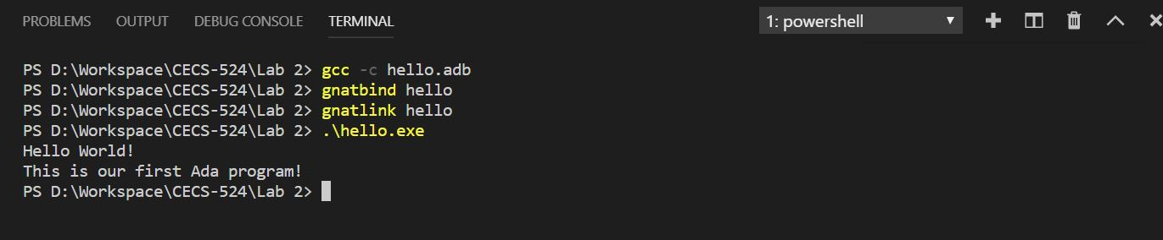

* Fortran Result:

